1. INTRODUCTION
TEMPERATURE: Degree of relative coldness and hotness.  Temperature is effect of kinetic energy of molecule present in the substance.  Kelvin Temperature Scale: No Negative term in the temperature.  0 K = 0 kinetic energy of molecule.  Absolute Temperature: Temperature measured with respect to absolute zero kelvin temperature.  TK = TC + 273.  PRESSURE:  1) Normal Force exerted per unit area.  2) Rate of change of moment per unit area. | 
$$P= {\frac{dM}{dt}}/{Area}=\frac{F_{n}}{Area}$$
Absolute Pressure:
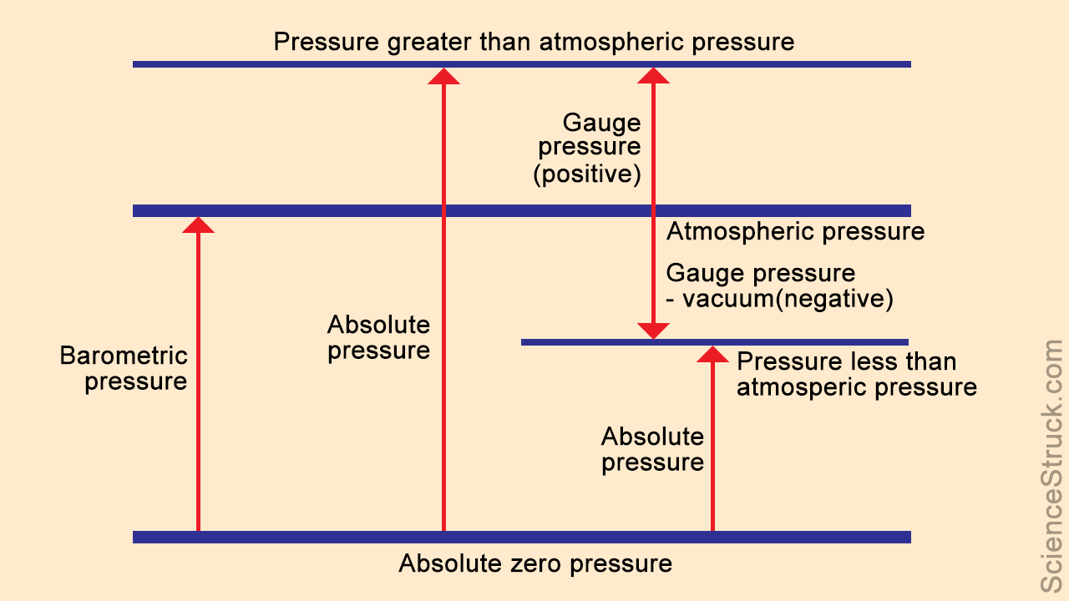
Physical meaning of volume:
gas $\underset{→}{∆}$ Molecules move away => volume increase => Velocity increases => Kinetic energy increases | gas $\underset{→}{-∆}$ Molecules come together => volume decrease => Velocity Decreases => Kinetic energy Decreases

Macroscopic Approach | Microscopic Approach
Average molecules behaviour | Each/individual molecules behaviour
Classical Thermodynamics | Statistical Thermodynamics because Large number of equations required to be solved
Qty uses: Average P, T, V
Use in internal combusting engine, RAC, Power Plants | Use in Plasma, Laser, Missiles
Continuum Hypothesis: Metter is continuous function of space, time.
1 m³ => 2.4* 10²⁴ Molecules
Mean Free Path: Average distance between molecules.
MFP < Characteristic length (Continuum concept is valid)
Highly vacuum condition /at high elevations /Rarefied Gases /MFP > Characteristic length (Continuum concept is not valid)
Because elevations ˄ => Pressure ˅ => Density ˅ => Volume ˄ => MFP ˄

